**DAY 7_ELASTIC LOAD BALANCERS**

DAY 7_ELB_CE1

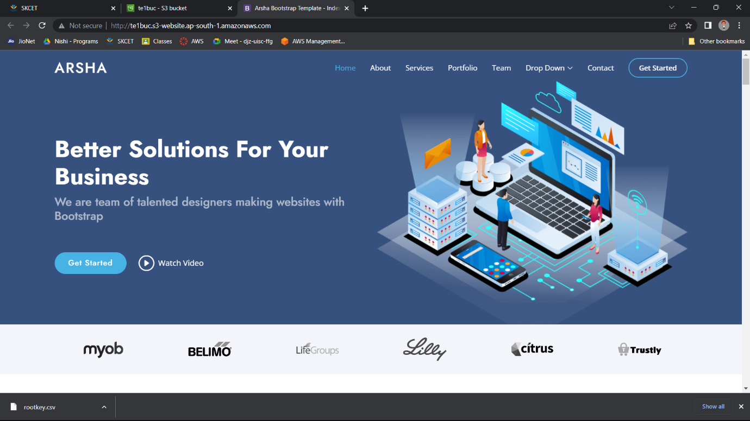

DAY 7_ELB_CE2

